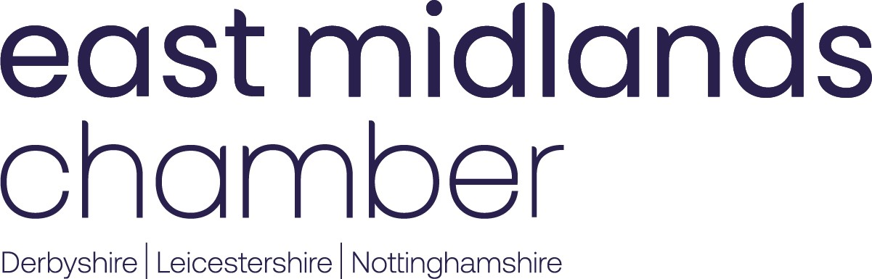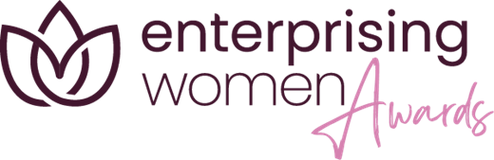

**Enterprising Women Social Commitment 2025**

**Sponsored by Tomato Energy**

**Closing Date: 11 April 2025, 5pm**

**This award is open to women who demonstrate an innovative and proactive approach to corporate social responsibility and responsible business practice. Entrants must be able to demonstrate how they have tackled key social or environmental issues to make a positive impact on their local community.**

**Instruction**

Thank you for your interest in applying for the East Midlands Chamber (Derbyshire, Nottinghamshire, Leicestershire) Enterprising Women Awards 2025. These awards celebrate and showcase the successes of women in business that have taken place in the East Midlands region over the past year.

To support a valid entry, before completing this application please carefully read the accompanying guidelines for applying.

*Please note: Applications have a strict 2,000 word limit. This document currently contains 785 words which consists of instructions and questions. Therefore, the total word count of this entire document once completed must be no more than 2785 words.*

A maximum of 2 attachments (e.g., tables, graphs or photos) may be included with the entry form. These attachments must be image files (jpg, gif, png or tif) and must not exceed 5MB in total. Any attachments that exceed the permitted allowance or exceed the permitted file size will be deleted.

Please save your completed form as a word document using the format yourname_yourcompany__awardcategory.doc (Example: JaneDoe_EastMidlands Chamber_Employee of the Year.doc) and email to [events@emc-dnl.co.uk](mailto:events@emc-dnl.co.uk).

The closing date is **5pm on 11 April 2025.**

The Chamber and Enterprising Women team looks forward to receiving your entry and wishes you the best of luck.

|  |  |  |
| --- | --- | --- |
| TOTAL WORD COUNT |  |  |

|  |  |
| --- | --- |
| Contact name (if nominating on someone’s behalf) |  |
| Contact email (if nominating on someone’s behalf) |  |
| Name of entrants |  |
| Company name |  |
| Company address |  |
| Email address |  |
| Web site address |  |
| Telephone number |  |
| LinkedIn account |  |
| Business sector |  |
| Nature of business |  |
| Main product/service |  |
| Number of employees |  |
| Chamber Membership Number |  |

1. **Please provide a brief description of the business, the products or services it supplies, its customers and the markets that it operates in.**

You should cover:

* The nature of your business
* Your products and services
* Your customers
* Markets that you operate in
* Reason for entering into the Enterprising Women Awards

**PLEASE NOTE:** This description will be provided as an overview to the East Midlands Chamber marketing team should you be successfully shortlisted as a finalist, which will be used in any marketing activity including event programmes and finalist videos. Please make sure you happy with the content in submission as the Chamber cannot be held responsible for making amendments.

**(Please complete in no more than 200 words)**

1. **What are your CSR policies and how have they been developed?**

You should provide:

* Details of your CSR policies
* How these have been developed
* Details of policy targets and key performance indicators
* Information on how the policies have been incorporated into your overall business plan

1. **Outline how your CSR policies/best practice policies have had a positive effect in your/the workplace?**

You should cover:

* Any new products or services developed and how they were developed
* The impact this has had on overall business performance
* Details of the impact your policies have had on your staff, or yourself as an individual
* Examples of activities such as recycling initiatives, reducing energy consumption, carpool schemes

1. **How have your responsible business practices helped address issues in the local community?**

You should identify:

* Issues in the local community
* How your practices have helped to address these issues
* The outcome of these issues being addressed

1. **Please describe why you think you / the entrant should win the Social Commitment Award.**